

**Practical file**

**CS-502**

**DataBase Management System**

**SUBMITTED BY:- SUBMITTED TO:-**

**SHIVANI KUSHWAH MRS ARCHANA TOMAR**

**(0905CS201162) ASST.PROFESSOR DEPT CSE**

**INDEX**

|  |  |  |  |  |
| --- | --- | --- | --- | --- |
| **S. No.** | **Title** | **Date** | **Signature** | **Remark** |
| **1.** | **DDL AND DML COMMANDS** | **25/03/22** |  |  |
| **2.** | **Primary key, candidate key, foreign key, not null, unique, default constraints.** | **01/04/22** |  |  |
| **3.** | **Max, min , avg, count, sum, last, upper .** | **01/04/22** |  |  |
| **4.** | **Join Operation** | **08/04/22** |  |  |
| **5.** | **Index.** | **08/04/22** |  |  |
| **6.** | **Transaction Control Language: Commit, Rollback, Set Transaction** | **22/04/22** |  |  |
| **7.** | **Views Implementation.** | **06/05/22** |  |  |
| **8.** | **Control Flow.** | **13/05/22** |  |  |

Experiment-1

**Mysql Introduction**

MySQL is a fast, easy-to-use RDBMS being used for many small and big businesses. MySQL is developed, marketed and supported by MySQL AB, which is a Swedish company. MySQL is becoming so popular because of many good reasons –

* MySQL is released under an open-source license. So you have nothing to pay to use it.
* MySQL is a very powerful program in its own right. It handles a large subset of the functionality of the most expensive and powerful database packages.
* MySQL uses a standard form of the well-known SQL data language.
* MySQL works on many operating systems and with many languages including PHP, PERL, C, C++, JAVA, etc.
* MySQL works very quickly and works well even with large data sets.
* MySQL is very friendly to PHP, the most appreciated language for web development.
* MySQL supports large databases, up to 50 million rows or more in a table. The default file size limit for a table is 4GB, but you can increase this (if your operating system can handle it) to a theoretical limit of 8 million terabytes (TB).
* MySQL is customizable. The open-source GPL license allows programmers to modify the MySQL software to fit their own specific environments.

**Experiment-2**

**Introduction of library management system dbms**

In library management system, we will build Library Management System using MYSQL. We will build the database, which includes tables. Imagine that you go to the library, take a book, and just enter that book into the computer rather than entering your details and book details in a register. Isn’t it easy and convenient? Here comes the library management system. This system is handy for people going to the library and searching for their desired book and for the librarian to guide them and take care of these things. It ensures that everything works in systematic order, given that each person taking or returning books needs to enter the record in the system.

Number of Modules:-

The project has been designed as three-modules web application Admin, student and librarian are the major modules of library management system project.

1. *Admin Module:*The programme administrator will be in charge of the admin module. He is the one in charge of the application's security and authorization. Only the admin can register the different librarians with the application and the database. The librarians can only access the application if they are authorised and registered. He has full access to the whole application and manages the overall functioning of the software. If somebody has a problem with anything, they should first contact the administrator.
2. *Librarian Module:*The librarian has full access to the librarian module. So, whenever a librarian opens the application, he has to login in the application with the user id and password provided by the admin. The various actions that he can undertake are visible on the home screen after a successful login. The operations he can perform includes: add new students, add new books, issue books, return books, updating student’s details, updating book’s details, sending messages to the students regarding various issues (like overdue of the issue book), generating weekly/monthly reports, monitoring any discrepancy in the books stock.
3. *Student Module:*The student module contains details about all the students registered with the library. Only the librarian can register the students with the application after successful verification. The operations that student can perform inside the student module includes: view all books available in the library, search the availability of a particular book, number of books he has issued from the library, overall fine that he has to pay, submit the queries. Apart from this, the students can cancel their registration from the library.

Experiment-3

**Max, min, count, avg, sum, last, upper, etc.**

•**COUNT FUNCTION** - The COUNT function returns the total number of values in the specified field. It works on both numeric and non-numeric data types.

•**MIN FUNCTION** - The COUNT function returns the total number of values in the specified field. It works on both numeric and non-numeric data types.

•**MAX FUNCTION** - The MAX function is the opposite of the MIN function. It returns the largest value from the specified table field.

•**SUM FUNCTION -** MySQL SUM function which returns the sum of all the values in the specified column. SUM works on numeric fields only. Null values are excluded from the result returned.

•**AVG FUNCTION** - AVG function returns the average of the values in a specified column. Just like the SUM function, it works only on numeric data types.

•**UPPER FUNCTION** - The UPPER() function to convert any lowercase characters to uppercase.

•**LOWER FUNCTION** - MySQL last function is used to return the last

value of the selected column.

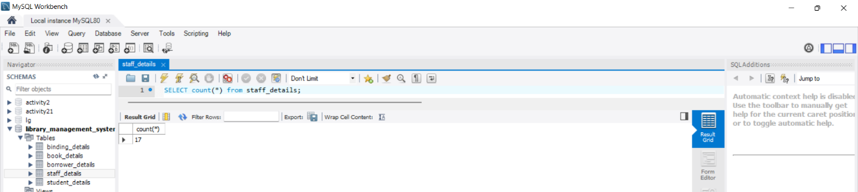

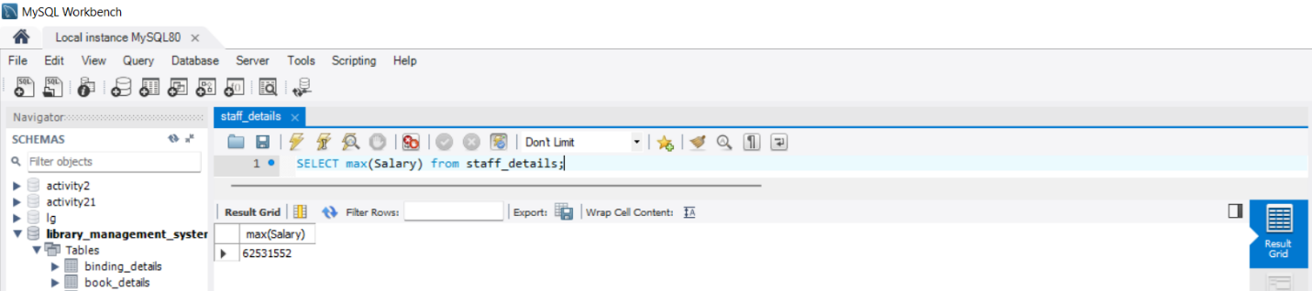

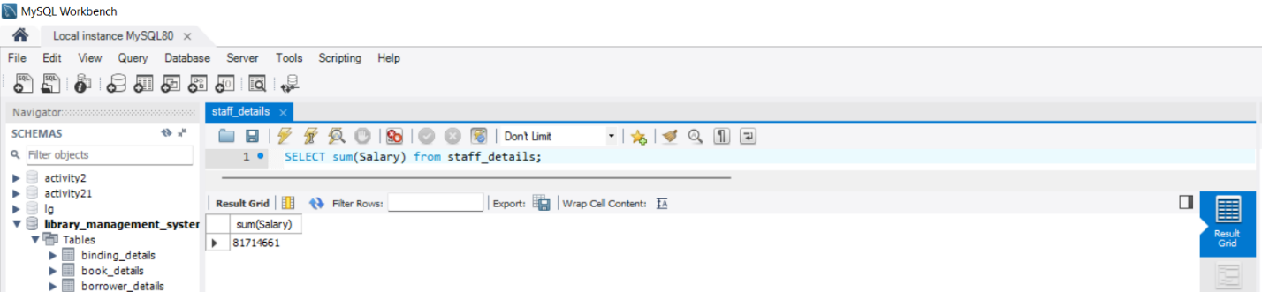

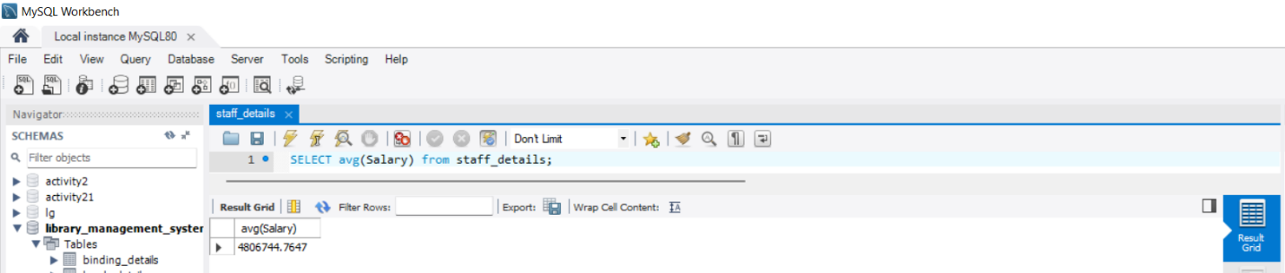

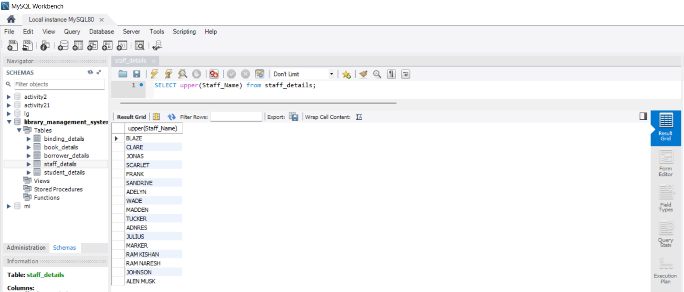

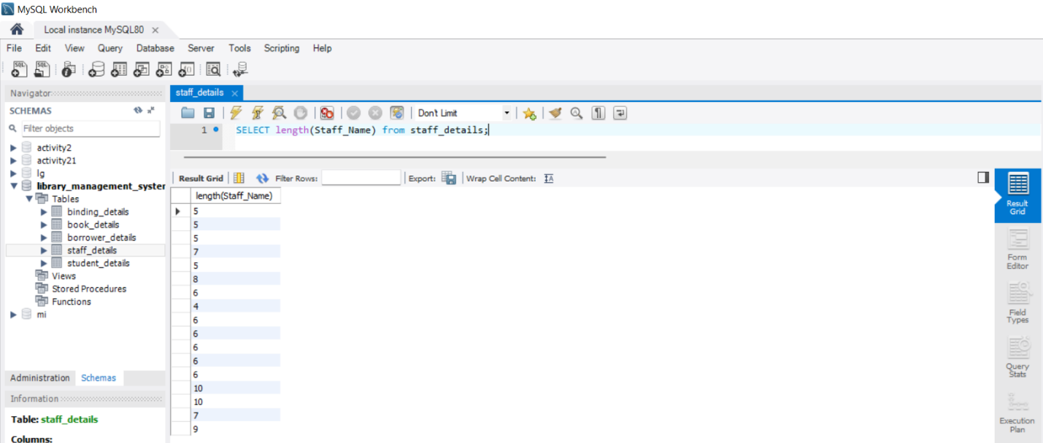

**Experiment-4**

**JOIN Operation: inner join ,left join ,right join, cross join, natural join**

**JOIN FUNCTION** - MySQL last function is used to return the last value of the selected column.

**INNER JOIN** - The INNER JOIN selects all rows from both participating tables as long as there is a match between the columns.

**LEFT JOIN** - he LEFT JOIN allows you to query data from two or more tables. Similar to the

**INNER JOIN-** clause, the LEFT JOIN is an optional clause of the SELECT statement, which appears immediately after the FROM clause. Suppose that you want to join two tables t1 and t2.

**RIGHT JOIN** - The Right Join is used to joins two or more tables and returns all rows from the right-hand table, and only those results from the other table that fulfilled the join condition. If it finds unmatched records from the left side table, it returns Null value.

**CROSS JOIN** - MySQL CROSS JOIN is used to combine all possibilities of the two or more tables and returns the result that contains every row from all contributing tables. The CROSS JOIN is also known as CARTESIAN JOIN, which provides the Cartesian product of all associated tables.

**NATURAL JOIN** - A NATURAL JOIN is a JOIN operation that creates an implicit join clause for you based on the common columns in the two tables being joined. Common columns are columns that have the same name in both tables. A NATURAL JOIN can be an INNER join, a LEFT OUTER join, or a RIGHT OUTER join. The default is INNER join.

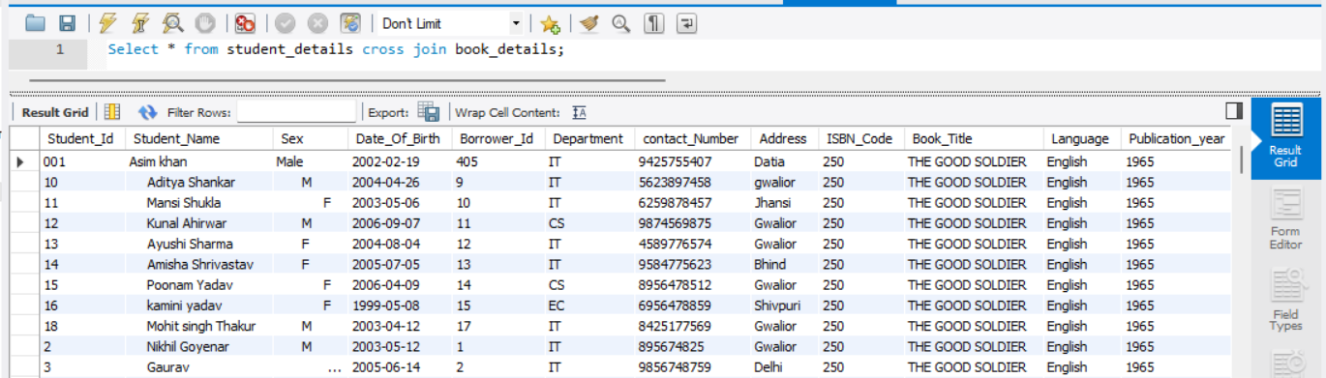

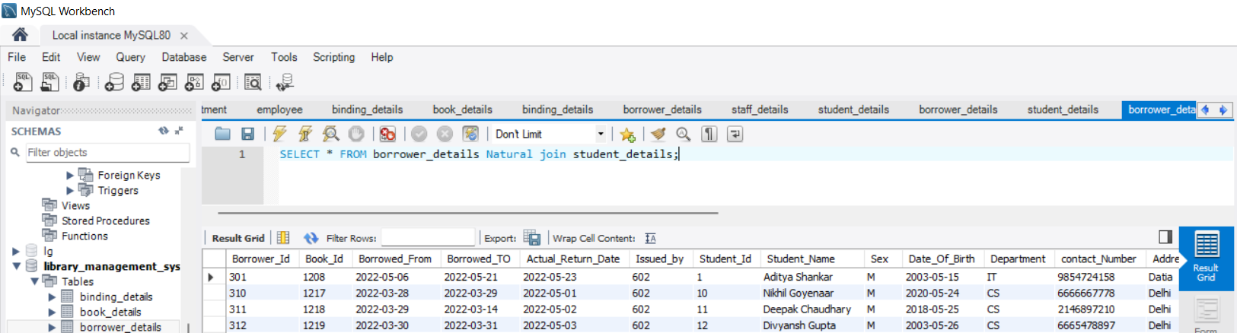

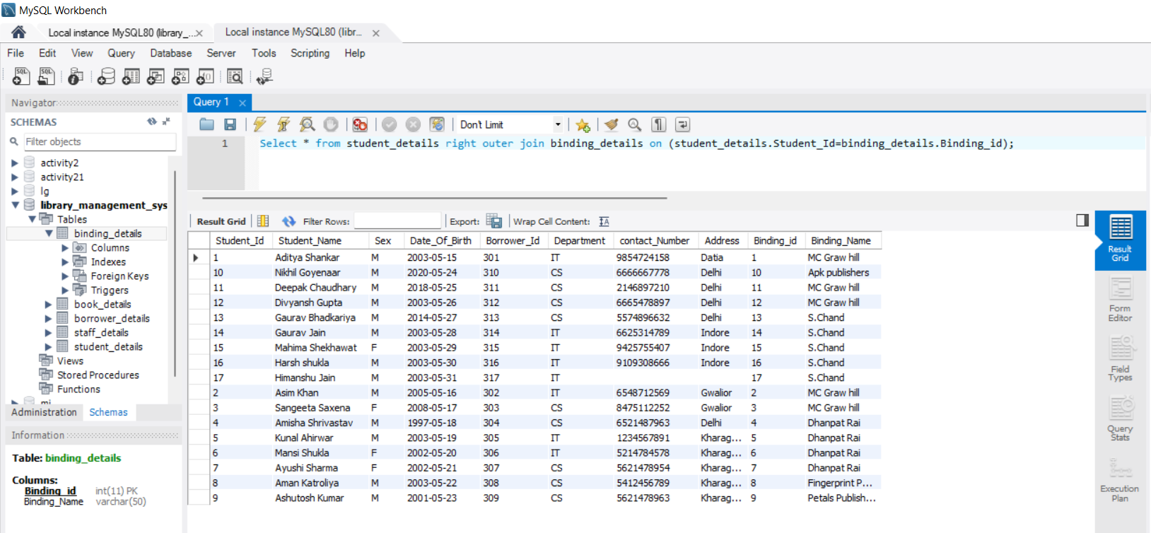

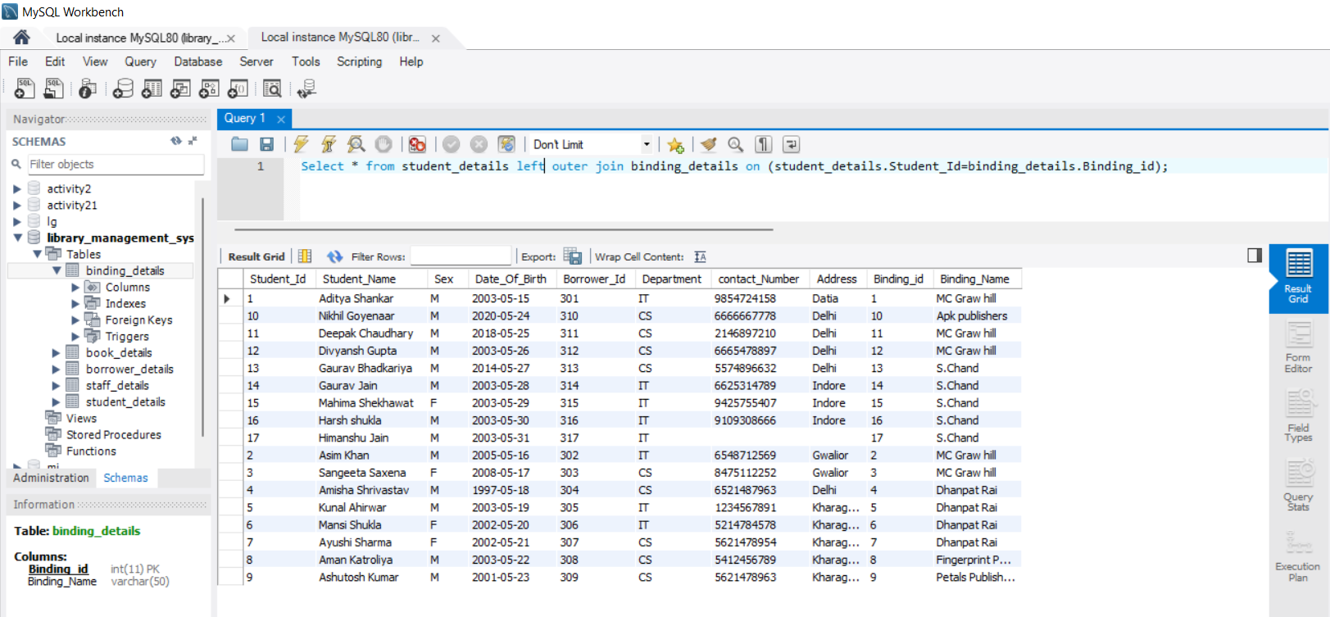

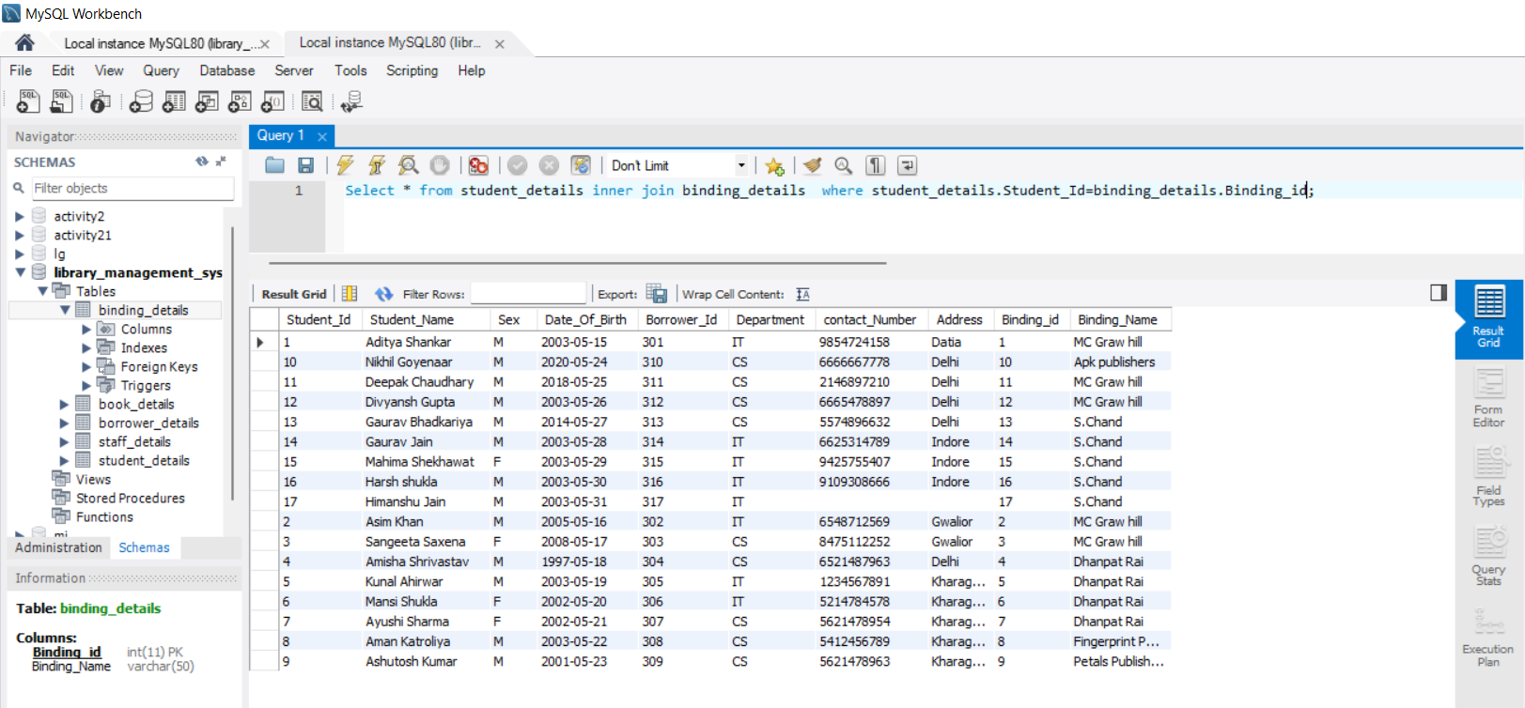

**EXPERIMENT-5**

**Index**

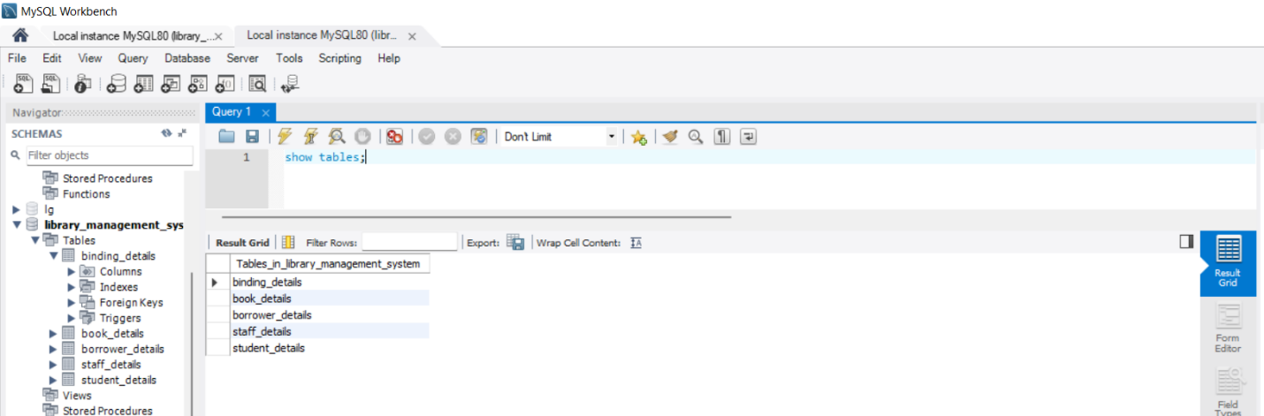

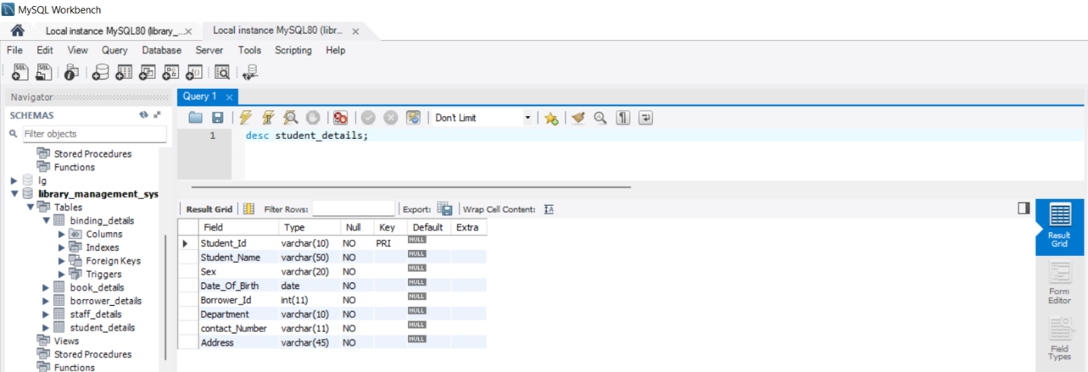

**EXPERIMENT-6**

**Transaction control language: commit ,rollback, set Transaction**

**TCL - Transaction Control Language(TCL)** commands are used to manage transactions in the database. These are used to manage the changes made to the data in a table by DML statements. It also allows statements to be grouped together into logical transactions.

**COMMIT-** COMMIT command is used to permanently save any transaction into the database.

**ROLLBACK-** This command restores the database to last committed state. It is also used with SAVEPOINT command to jump to a save point in an ongoing transaction.

**SET TRANSACTION -** The operations performed by a SET TRANSACTION statement affect only your current transaction, not other users or other transactions.

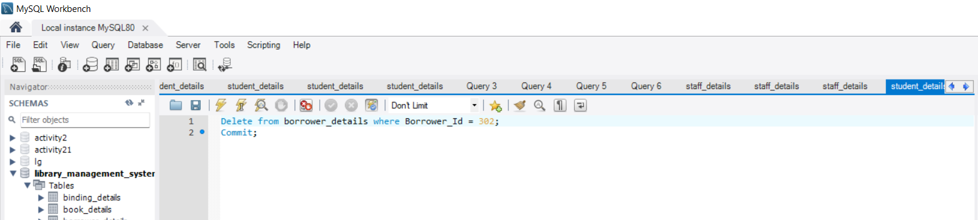

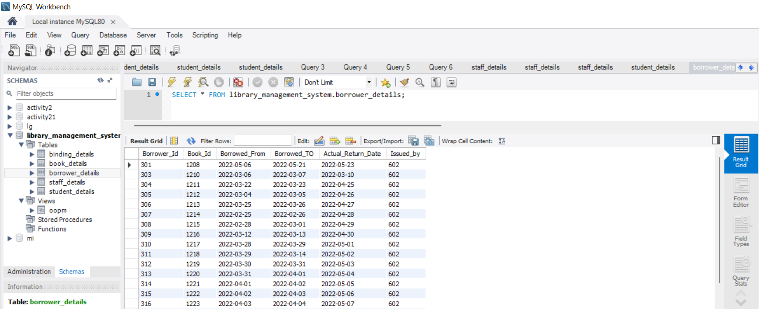

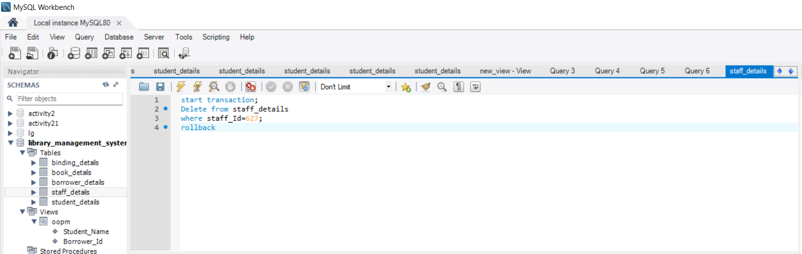

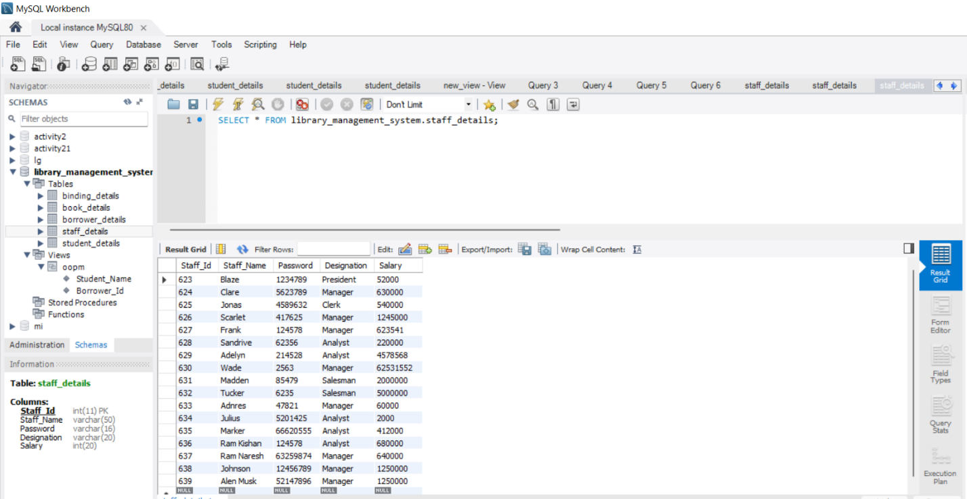

**EXPERIMENT-7**

**VIEWS IMPLEMENTATION**

**VIEW** - A database view is a subset of a database and is based on a query that runs on one or more database tables.

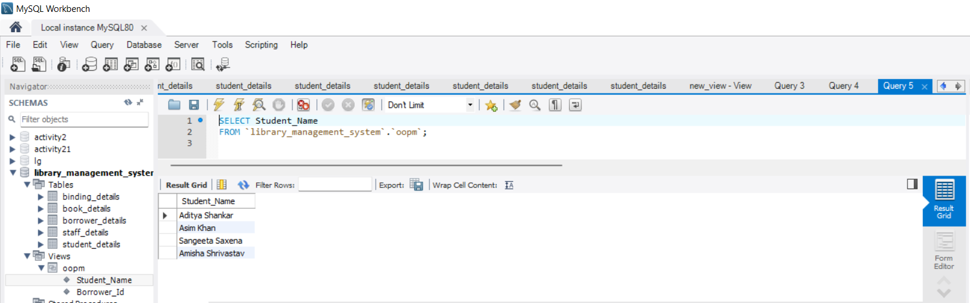

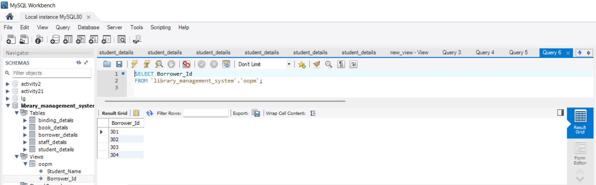

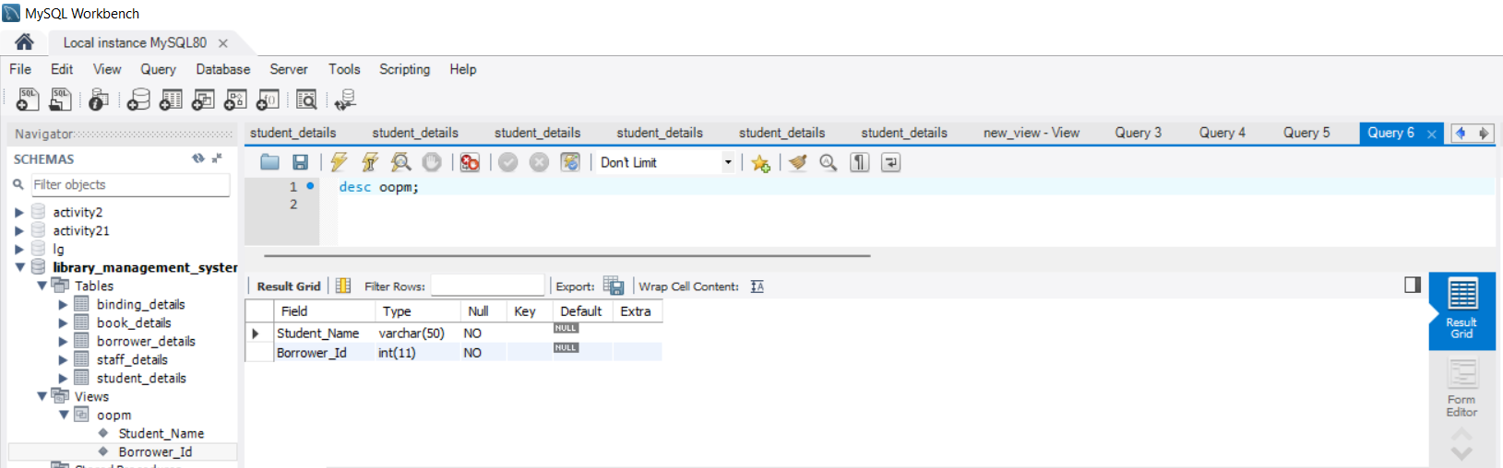

**EXPERIMENT-8:**

**CONTROL FLOW**

**CONTROL FLOW-** An operation that controls the recording or processing or transmission of interpretation of data; "a control operation started the data processing.

